Coburg North Primary School Theircare service

Weekly Recap!

Term 4 Week 1
04/10/21 – 08/10/21

Welcome Back!
It was lovely to be back, and even better to know that the children will all be returning during this term. We cannot wait to have lots of laughter, fun and noise back in the service. Currently we are preparing for the children’s return and for the hotter weather.
Changes will be made to the Italian Room it will become a “chilled-out” room where the children can enjoy the air con on hot days and also to be able to escape the noise and maybe read a book, play a quiet game or for the older children to pull up a beanbag and chill out and chat. It opens many other options for those not wanting to do arts or crafts or be outside. If you or your children have any ideas for this, please let us know, we will be working with the children upon their return in how they want the room too.
Week 1 – Welcome Back!
This week has been all about reconnection with the children, hearing their holidays stories, having fun in the sun, and celebrating a birthday of one of the Preps with a little party. We have talked about friendships and personal bubbles. We made hats on Wednesday for Mad Hatters Day too, and Taco craft Monday for National Taco Day!
Next Week:
National Nutrition Week Try for 5 – We always have a varied and healthy afternoon tea here at the OSHC program, but we are going to use the children’s prior knowledge and experience to share with others their favourite healthy foods. We will even try to write our own recipe book.

Things To Remember:
- Term 4 is “No Hat No Play” – we are a SunSmart Service; therefore, the Daily UV will be checked, and children need bucket sun hats and sunscreen to be able to play outside on an afternoon.
- With staggered starts commencing in Week 3, we will run in line with school on the children wearing masks – “Recommended for Primary Students.”
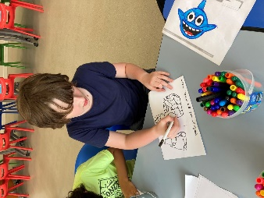
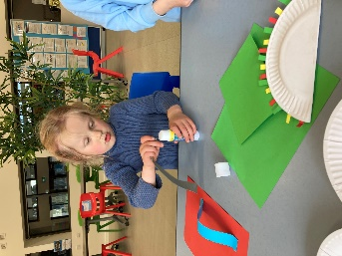
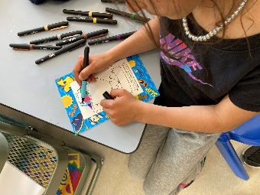
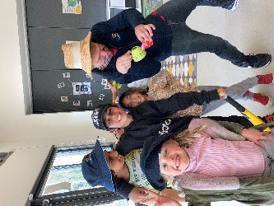
- Please ensure that when collecting your children that you sign in with the QR Code and wear your mask please.
Photo Hi-lights of the Week

Taco Monday and Mad Hatters Wednesday Craft
“No Hat No Play” we are SunSmart kids

Working Next Week – 11/10/21

Staff | Monday | Tuesday | Wednesday | Thursday | Friday
Nikki Cotterill | 7-11 am & 2.00-6.00pm | 7-11 am & 2.30-6.00pm | 7-10 am & 12.30-6.00pm | 7-10.00 am & 2.00-6.00pm | 7-10.30 am & 2.30-6.00pm
Asefeh Zamani | 12.00-6.00pm | 12.00-6.00pm | 12.00-6.00pm | 12.00-6.00pm | 12.00-6.00pm
Chantelle Daher | 7-9 am & 2.30-6.00pm | 7-9 am & 2.30-6.00pm | 7-9 am & 2.30-6.00pm | 7-9 am & 2.30-6.00pm
Cameron Mighell | 2.30-6.00pm | 2.30-6.00pm | 2.30-6.00pm | 2.30-6.00pm | 2.30-6.00pm
Luke Morrow | 7-9am | 7-9am | 7-9am | 7-9am | 7-9am

